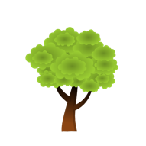

ST SAMPSON’S CHURCH
SOUTH HILL
‘SUNDAY WITH A DIFFERENCE’

Every fourth Sunday we do something slightly less formal.

Not too different but a chance to explore other ways of worshipping. Be prepared to be surprised, inspired and challenged whatever your age or faith background.

One month it’s Forest Café Church – outside for some of the time, weather permitting.
Coffee, tea, juice, cake, biscuits available throughout.

The other month follows a more traditional pattern but will always be less formal.
Coffee, tea, juice, cake, biscuits afterwards.

Something for All Ages at Every Service.
Everyone is Welcome – Come and See!

